***INTERNATIONAL WOOD COLLECTORS SOCIETY***

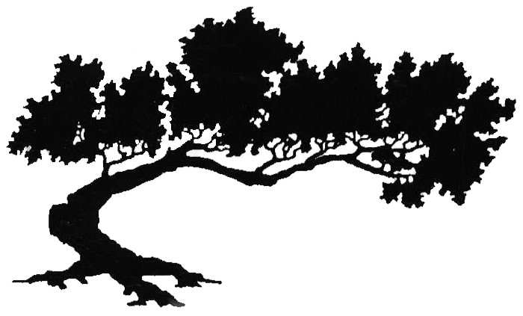

***AUSTRALASIAN REGION***

**AUSTRALIAN MEMBERSHIP PAYMENT AND RENEWALS**

Members of IWCS residing in Australia have two options for the payment of membership fees.

**Option One**. Process your membership application and renewals through our Australian Membership Secretary at [schubertwoodturning@gmail.com](mailto:schubertwoodturning@gmail.com) Current annual fees are shown below. Regular membership includes a hard copy of World of Wood (WOW) and on-line access to all issues of WOW. Renewals can be handled in the same manner. Membership may be renewed for up to three years at a time saving you from annual administrative processes. Current fees are:

|  |  |
| --- | --- |
|  | Regular Membership |
| One year | $80 AUSD |
| Two years | $160 AUD |
| Three years | $240 AUD |

Our Membership Secretary will advise you approximately one month prior to your renewal becoming due. The Region transfers all membership fees to our parent body in February/March each year.

**Option Two**. Apply and pay on line via the IWCS website <https://woodcollectors.org> Current annual fees are shown below. Regular membership includes a hard copy of World of Wood (WOW) and on-line access to all issues of WOW whereas for On-line membership WOW is accessible via the members only section of the website. Renewals can be handled in the same manner. Membership may be renewed for up to three years at a time saving you from annual administrative processes; current fees are:

|  |  |  |
| --- | --- | --- |
|  | Regular Membership | On-line Membership |
| One year | $55 USD | $45 USD |
| Two years | $110 USD | $90 USD |
| Three years | $165 USD | $135 USD |